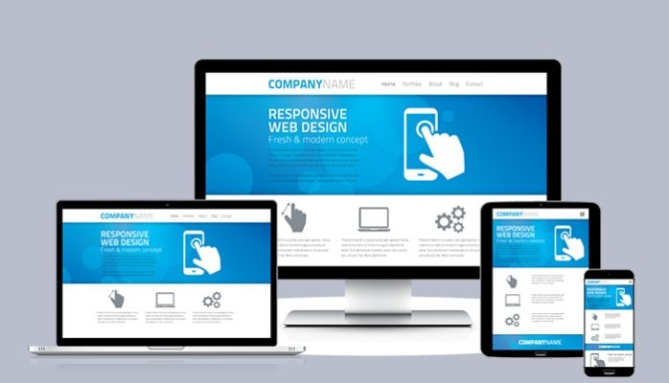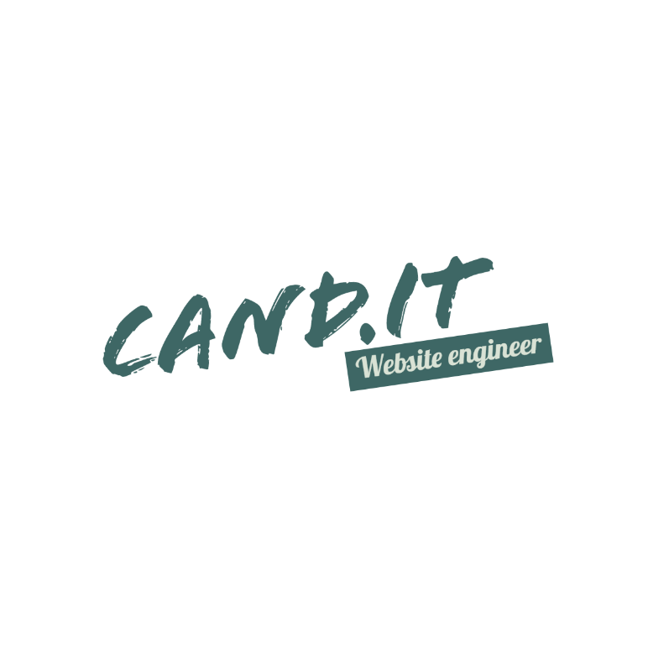

* **Page designs**
* **Speed optimization**
* **Domain names (.co.ke .com)**
* **Unlimited professional Emails**
* **Social media integration**
* **Contact forms**
* **Mobile optimized**

**PACKAGE INCLUDES**

**TRANSFORM YOUR ONLINE PRESENCE**

**WITH OUR ASTONISHING WEBSITES**